**Thyroid disease classification using**

**ML**

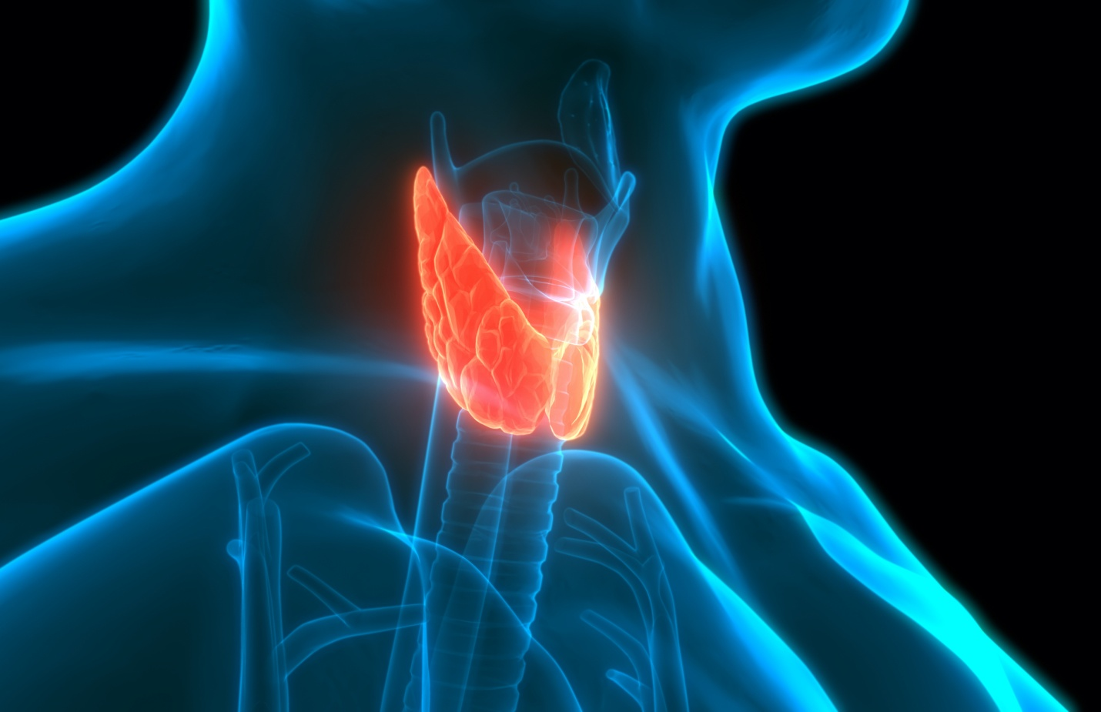

Project Report Template

# 1. INTRODUCTION

**1.1 Overview**

The Thyroid gland is a vascular gland and one of the most important organs of the human body. The two types of Thyroid disorders are Hyperthyroidism and Hypothyroidism. A thyroid-related Blood test is used to detect this disease but it is often blurred and noise will be present. Machine learning plays a very deciding role in disease prediction. Machine Learning algorithms, SVM-support vector machine, Random Forest Classifier, XGB Classifier and ANN-Artificial Neural Networks are used to predict the patient’s risk of getting thyroid disease. The web app is created to get data from users to predict the type of disease.

**1.2 Purpose**

The main purpose is to search the best Classification approach for thyroid disease diagnosis by making the comparison of decision tree algorithms. Data cleansing methods were used to make the data primitive enough for the analytics to show the risk of patients getting this disease. The thyroid disease can be easily identified based on the symptoms in the patient’s history. Based on the input, this Classification predicts Thyroid disease in our body.

# 2. Problem Definition & Design Thinking

# 2.1 Empathy Map

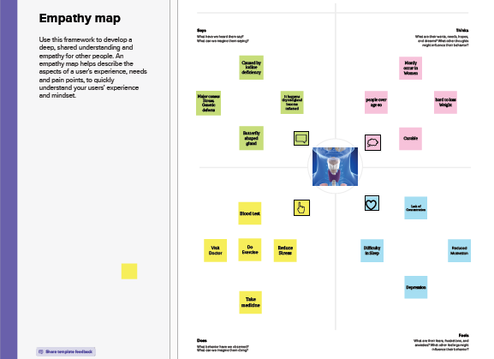

# 2.2 Ideation &Brainstorming Map

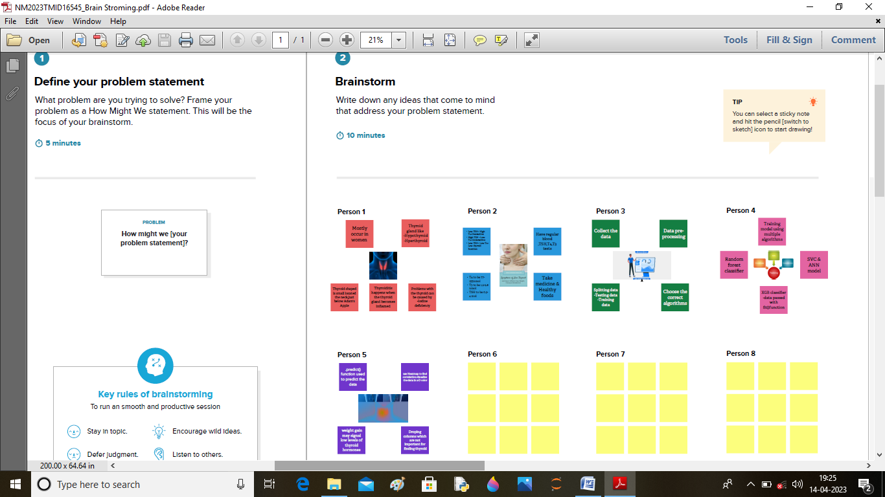

# 3. Results

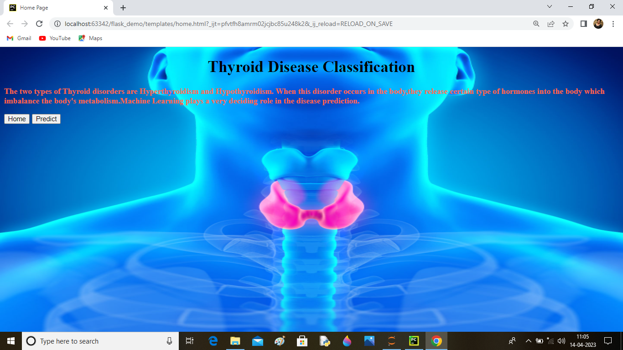

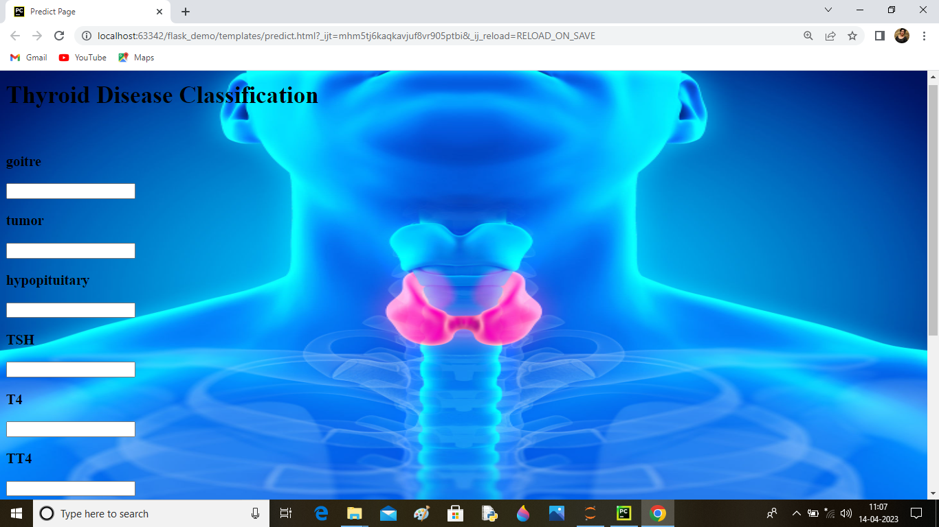

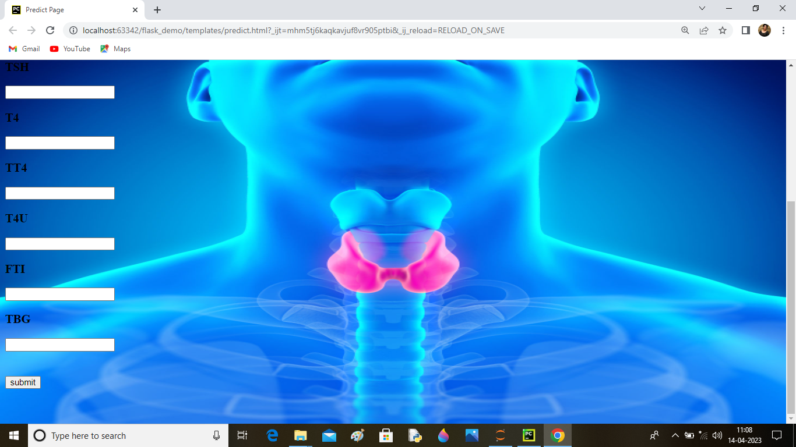

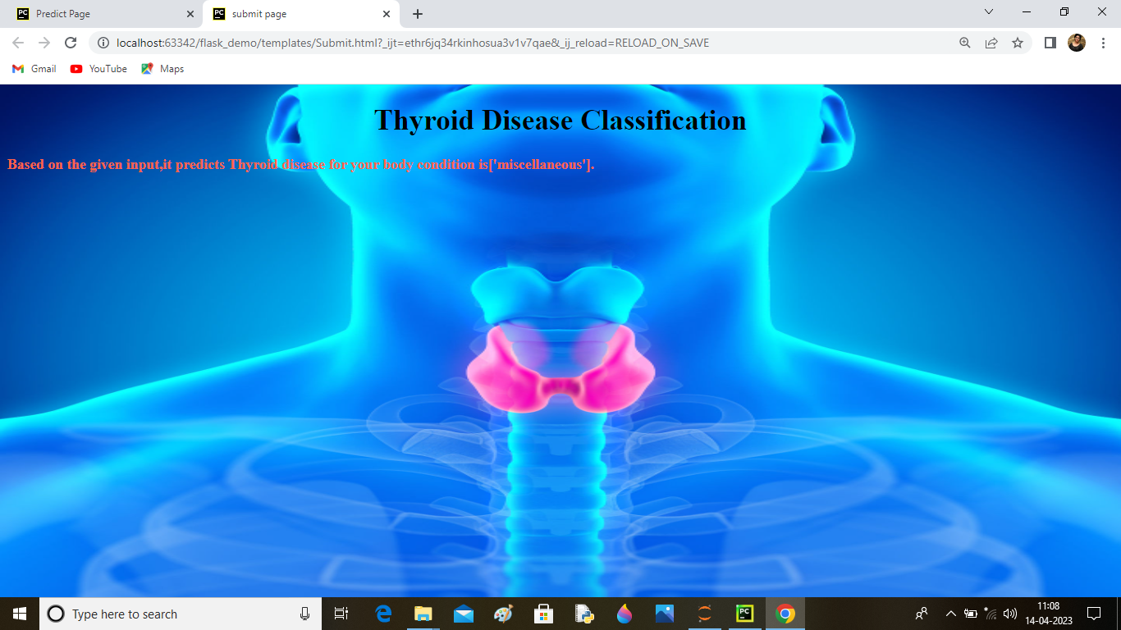

4. Advantages &Disadvantages

**Advantages:**

* Standardized method Easy Learning curve reduced operating time.
* This affects weight loss or weight gain is called the metabolic rate.
* Slowing down or speeding up your heart rate.

**Disadvantages:**

* Poor cosmetic result Hyper or paresthesia in the neck.
* Difficult learning curve Limits in nodules size.
* Greater postoperative pain difficult learning curve longer operating time complications from CO2 insufflation higher cost.

# 5. Applications:

* Thyroid hormone has many beneficial effects including enhancing cardiac function, promoting weight loss and reducing serum cholesterol.
* Excess thyroid hormone is however, associated with unwanted effects on the heart, bone and skeletal muscle.

6. Conclusion:

* Thyroid gland affects metabolism.
* Supplements may be harmful so use cautiously.
* Thyroid nodules are common but should be evaluated.

# 7. Future scope:

* The thyroid gland is a vital hormone gland. It plays a major role in the metabolism, growth and development of the human body.
* It helps to regulate many body functions by constantly releasing a steady amount of thyroid hormones into the blood
* Thyroid endocrinology aims to advance our knowledge of the physiopathology of the thyroid gland.
* The big exception is iodine deficiency, which represents the most common thyroid disease for all ages.

# 8. Appendix

## A .Source Code

